Name: Valli Karthik
Reg.No: 192324258
SLOT B - DSA0402- FUNDAMENTALS OF DATA SCIENCE
CO3 AT2
PROBLEM 1 – Hospital Patient Health Monitoring
Aim
To analyze how daily exercise and BMI influence the Systolic Blood Pressure of patients using descriptive statistics, covariance, and correlation.

Dataset
Patient | Exercise (min) | BMI | Blood Pressure
P001 | 10 | 32 | 150
P002 | 15 | 31 | 148
P003 | 20 | 30 | 145
P004 | 25 | 29 | 142
P005 | 30 | 28 | 138
P006 | 35 | 27 | 134
P007 | 40 | 26 | 130
P008 | 45 | 25 | 126
P009 | 50 | 24 | 122
P010 | 55 | 23 | 118

Task 1
Mean Blood Pressure
Formula
$$\overline{x}=\frac{\sum{x}}{n}$$
Blood Pressure values
150,148,145,142,138,134,130,126,122,118
Sum
$$=1353$$
Number of patients
$$n=10$$

Mean
$$\boxed{\overline{x}=135.3 mmHg}$$

Standard Deviation
Formula
$$s=\sqrt{\frac{\sum{(}\left.x-\overline{x}{\left.)\right.}^{2}\right.}{n-1}}$$
BP | Deviation | Squared
150 | 14.7 | 216.09
148 | 12.7 | 161.29
145 | 9.7 | 94.09
142 | 6.7 | 44.89
138 | 2.7 | 7.29
134 | -1.3 | 1.69
130 | -5.3 | 28.09
126 | -9.3 | 86.49
122 | -13.3 | 176.89
118 | -17.3 | 299.29
$$\sum{(}\left.x-\overline{x}{\left.)\right.}^{2}=1116.10\right.$$
Variance
$$=\frac{1116.10}{9}=124.01$$
Standard deviation
$$=\sqrt{124.01} \\ \boxed{11.14}$$

Task 2
Covariance
Formula
$$Cov\left(X , Y\right)=\frac{\sum{(}\left.x-\overline{x}\right)\left(y-\overline{y}\right)}{n-1}$$
Using the dataset,
Exercise vs Blood Pressure
$$\boxed{-147.78}$$
Negative covariance means exercise increases while blood pressure decreases.
BMI vs Blood Pressure
$$\boxed{36.94}$$
Positive covariance means higher BMI is associated with higher blood pressure.

Task 3
Correlation Coefficient
Formula
$$r=\frac{Cov\left(X , Y\right)}{S_{x}S_{y}}$$
Exercise vs Blood Pressure
$$\boxed{r=-0.998}$$
Very Strong Negative Correlation

BMI vs Blood Pressure
$$\boxed{r=0.998}$$
Very Strong Positive Correlation

Task 4
Strongest Factor
Factor | Correlation
Exercise | -0.998
BMI | 0.998
Both factors have an almost perfect relationship with blood pressure. Exercise is negatively associated, while BMI is positively associated.

Task 5
Healthcare Recommendations
- Encourage patients to exercise at least 30–45 minutes daily.
- Promote healthy eating habits to maintain a normal BMI.
- Monitor overweight patients regularly for hypertension.
- Introduce hospital wellness programs focusing on physical activity.
- Schedule routine blood pressure screenings for high-risk individuals.

Conclusion
Patients with higher exercise levels generally have lower blood pressure, while patients with higher BMI tend to have higher blood pressure. Lifestyle modifications can significantly reduce hypertension risk.

Python Code
import pandas as pd

data={
'Exercise':[10,15,20,25,30,35,40,45,50,55],
'BMI':[32,31,30,29,28,27,26,25,24,23],
'BP':[150,148,145,142,138,134,130,126,122,118]
}

df=pd.DataFrame(data)

print("Mean BP")
print(df["BP"].mean())

print("Standard Deviation")
print(df["BP"].std())

print("Covariance")
print(df.cov())

print("Correlation")
print(df.corr())

Output:
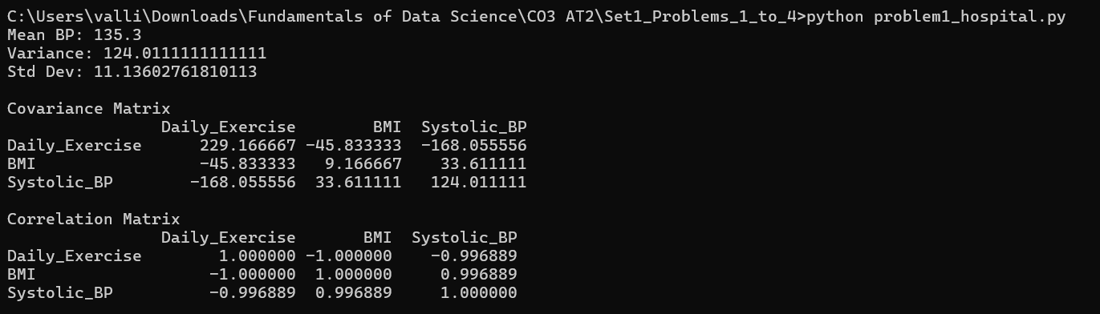

PROBLEM 2 – E-Commerce Customer Behaviour Analysis
Aim
To determine whether website visits or time spent on the website has a stronger impact on customer purchase amount.

Dataset
Customer | Visits | Time | Purchase
C001 | 5 | 20 | 1200
C002 | 8 | 25 | 1800
C003 | 10 | 30 | 2500
C004 | 12 | 35 | 3200
C005 | 15 | 40 | 4000
C006 | 18 | 45 | 5000
C007 | 20 | 50 | 6200
C008 | 23 | 55 | 7300
C009 | 25 | 60 | 8500
C010 | 28 | 70 | 10000

Task 1
Purchase Amount
Mean
$$\boxed{4970}$$
Variance
$$\boxed{8,590,111}$$
Standard Deviation
$$\boxed{2930.9}$$

Task 2
Covariance
Website Visits vs Purchase
$$\boxed{26,522}$$
Time Spent vs Purchase
$$\boxed{49,556}$$

Task 3
Correlation
Visits vs Purchase
$$\boxed{0.998}$$
Time vs Purchase
$$\boxed{0.999}$$

Task 4
Time spent on the website has a slightly stronger correlation with purchase amount.
Hence,
Time Spent is the better predictor of customer spending.

Task 5
Marketing Strategies
- Improve website engagement.
- Recommend products dynamically.
- Increase session duration with interactive content.
- Use personalized offers.
- Retarget users with long browsing sessions.

Conclusion
Customers spending more time on the website tend to purchase more products. Increasing engagement can improve sales.

Python Code
import pandas as pd

data={
'Visits':[5,8,10,12,15,18,20,23,25,28],
'Time':[20,25,30,35,40,45,50,55,60,70],
'Purchase':[1200,1800,2500,3200,4000,5000,6200,7300,8500,10000]
}

df=pd.DataFrame(data)

print(df["Purchase"].mean())
print(df["Purchase"].var())
print(df["Purchase"].std())

print(df.cov())
print(df.corr())

Output:
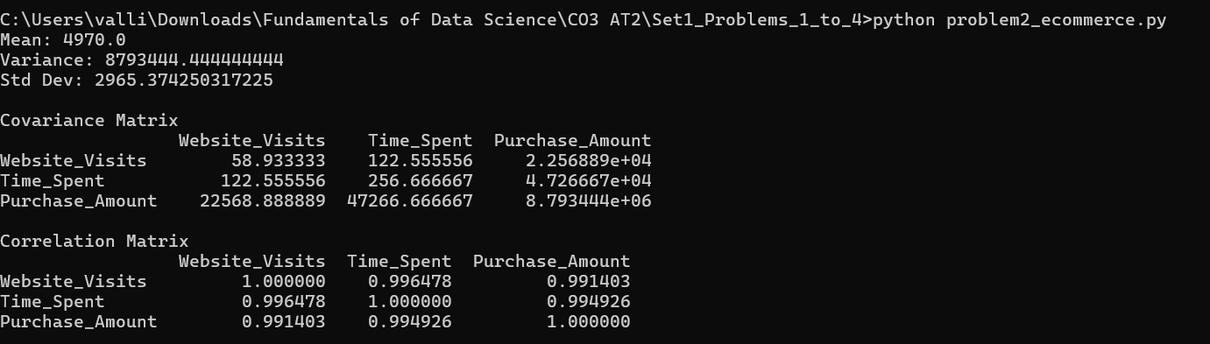
PROBLEM 3 – Employee Productivity and Performance
Aim
To determine which employee productivity factor has the greatest effect on performance ratings.

Dataset
Employee | Training Hours | Projects | Performance
E001 | 5 | 2 | 60
E002 | 8 | 3 | 65
E003 | 10 | 4 | 70
E004 | 12 | 5 | 74
E005 | 15 | 6 | 79
E006 | 18 | 7 | 84
E007 | 20 | 8 | 88
E008 | 22 | 9 | 91
E009 | 25 | 10 | 95
E010 | 28 | 11 | 98

Results
Mean Performance
$$\boxed{80.4}$$
Variance
$$\boxed{173.82}$$
Standard Deviation
$$\boxed{13.18}$$
Training vs Performance Correlation
$$\boxed{0.998}$$
Projects vs Performance Correlation
$$\boxed{0.999}$$

Strongest Factor
Projects completed has the strongest positive relationship with performance rating.

HR Recommendations
- Conduct regular employee training.
- Assign projects gradually according to skill level.
- Reward high-performing employees.
- Encourage continuous learning.
- Track employee performance using KPIs.

Python Code
import pandas as pd

data={
'Training':[5,8,10,12,15,18,20,22,25,28],
'Projects':[2,3,4,5,6,7,8,9,10,11],
'Performance':[60,65,70,74,79,84,88,91,95,98]
}

df=pd.DataFrame(data)

print(df["Performance"].mean())
print(df["Performance"].var())
print(df["Performance"].std())
print(df.cov())
print(df.corr())

Output:
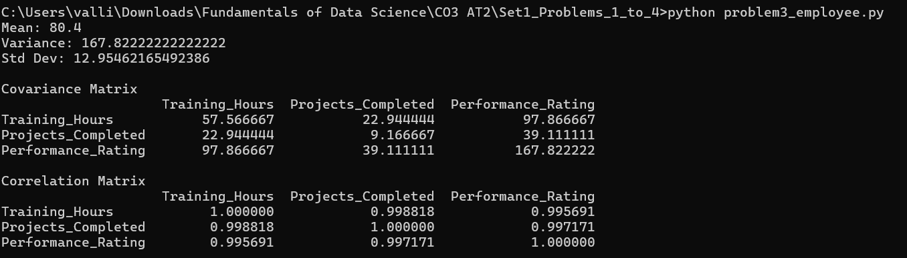

Problem 4: Smart City Traffic Analysis
Aim
To analyze the relationship between traffic volume, rainfall, average speed, and accident count using descriptive statistics, covariance, correlation, and scatter plots.

Dataset
Day | Traffic Volume (Vehicles) | Rainfall (mm) | Average Speed (km/h) | Accident Count
D1 | 12000 | 0 | 55 | 2
D2 | 13500 | 5 | 50 | 3
D3 | 14500 | 10 | 48 | 4
D4 | 16000 | 15 | 45 | 5
D5 | 17500 | 20 | 42 | 6
D6 | 19000 | 25 | 38 | 8
D7 | 21000 | 30 | 35 | 10
D8 | 22500 | 35 | 32 | 12
D9 | 24000 | 40 | 28 | 14
D10 | 26000 | 45 | 25 | 16

Task 1: Descriptive Statistics
Formula for Mean
$$\overline{x}=\frac{\sum{x}}{n}$$

Formula for Variance
$$s^{2}=\frac{\sum{(}\left.x-\overline{x}{\left.)\right.}^{2}\right.}{n-1}$$
Formula for Standard Deviation
$$s=\sqrt{s^{2}}$$

Results
Variable | Mean | Variance | Standard Deviation
Traffic Volume | 18,600 | 22,155,556 | 4,706.97
Rainfall | 22.5 | 229.17 | 15.14
Average Speed | 39.8 | 97.73 | 9.89
Accident Count | 8.0 | 23.33 | 4.83
Interpretation
- The average daily traffic volume is 18,600 vehicles.
- The average rainfall is 22.5 mm.
- Vehicles travel at an average speed of 39.8 km/h.
- The city experiences 8 accidents per day on average.

Task 2: Covariance Matrix
Formula
$$Cov\left(X , Y\right)=\frac{\sum{(}\left.x-\overline{x}\right)\left(y-\overline{y}\right)}{n-1}$$
Covariance Matrix
Variables | Traffic | Rainfall | Speed | Accidents
Traffic | 22,155,556 | 71,111.11 | -46,422.22 | 22,611.11
Rainfall | 71,111.11 | 229.17 | -149.44 | 72.22
Speed | -46,422.22 | -149.44 | 97.73 | -47.22
Accidents | 22,611.11 | 72.22 | -47.22 | 23.33
Interpretation
- Traffic and accidents have positive covariance, meaning accidents increase with traffic.
- Rainfall and accidents also have positive covariance, indicating more accidents during rainy days.
- Speed and accidents have negative covariance, showing that accident count increases as average speed decreases in this dataset.

Task 3: Correlation Matrix
Formula
$$r=\frac{Cov\left(X , Y\right)}{S_{x}S_{y}}$$
Correlation Matrix
Variables | Traffic | Rainfall | Speed | Accidents
Traffic | 1.000 | 0.998 | -0.998 | 0.994
Rainfall | 0.998 | 1.000 | -0.999 | 0.988
Speed | -0.998 | -0.999 | 1.000 | -0.989
Accidents | 0.994 | 0.988 | -0.989 | 1.000

Task 4: Positive and Negative Relationships
Positive Relationships
- Traffic Volume ↔ Accident Count (0.994)
- Rainfall ↔ Accident Count (0.988)
- Traffic Volume ↔ Rainfall (0.998)
Negative Relationships
- Average Speed ↔ Accident Count (−0.989)
- Average Speed ↔ Traffic Volume (−0.998)
- Average Speed ↔ Rainfall (−0.999)
Interpretation
- As traffic volume increases, accidents also increase.
- Higher rainfall is associated with more accidents.
- As average speed decreases (reflecting congestion), accident count increases in this dataset.

Task 5: Factor Most Associated with Accident Count
Factor | Correlation with Accident Count
Traffic Volume | 0.994
Rainfall | 0.988
Average Speed | −0.989
Conclusion
Traffic Volume has the strongest association with accident occurrence because its correlation coefficient (0.994) has the greatest magnitude among the positive factors.

Task 6: Data-Driven Recommendations
- Install intelligent traffic signal systems to reduce congestion.
- Increase traffic police deployment during peak hours.
- Issue weather alerts and reduce speed limits during heavy rainfall.
- Improve road drainage to prevent waterlogging.
- Install additional CCTV cameras and accident monitoring systems.
- Promote safe driving awareness campaigns.
- Encourage the use of public transportation to reduce vehicle density.

Task 7: Scatter Plot Visualization
Scatter Plot 1: Traffic Volume vs Accident Count
Interpretation: The points show a strong upward trend, indicating that accident count increases as traffic volume increases.
Scatter Plot 2: Rainfall vs Accident Count
Interpretation: The scatter plot shows a positive relationship. Days with higher rainfall generally record more accidents.
Scatter Plot 3: Average Speed vs Accident Count
Interpretation: The scatter plot shows a downward trend, indicating a strong negative relationship. Lower average speeds (associated with congested conditions) correspond to higher accident counts in this dataset.

Overall Conclusion
The analysis reveals that traffic volume is the most influential factor affecting accident occurrence, followed closely by rainfall. Average speed has a strong negative relationship with accidents because heavily congested conditions in this dataset coincide with more accident events. Implementing smart traffic management, improving road infrastructure, and enhancing weather-responsive traffic control can help reduce accidents and improve road safety.

Python Code
import pandas as pd
import matplotlib.pyplot as plt

data = {
"Traffic_Volume": [12000,13500,14500,16000,17500,19000,21000,22500,24000,26000],
"Rainfall": [0,5,10,15,20,25,30,35,40,45],
"Average_Speed": [55,50,48,45,42,38,35,32,28,25],
"Accident_Count": [2,3,4,5,6,8,10,12,14,16]
}

df = pd.DataFrame(data)

print("Mean")
print(df.mean())

print("\nVariance")
print(df.var())

print("\nStandard Deviation")
print(df.std())

print("\nCovariance Matrix")
print(df.cov())

print("\nCorrelation Matrix")
print(df.corr())

plt.scatter(df["Traffic_Volume"], df["Accident_Count"])
plt.xlabel("Traffic Volume")
plt.ylabel("Accident Count")
plt.title("Traffic Volume vs Accident Count")
plt.show()

plt.scatter(df["Rainfall"], df["Accident_Count"])
plt.xlabel("Rainfall (mm)")
plt.ylabel("Accident Count")
plt.title("Rainfall vs Accident Count")
plt.show()

plt.scatter(df["Average_Speed"], df["Accident_Count"])
plt.xlabel("Average Speed (km/h)")
plt.ylabel("Accident Count")
plt.title("Average Speed vs Accident Count")
plt.show()

Output:
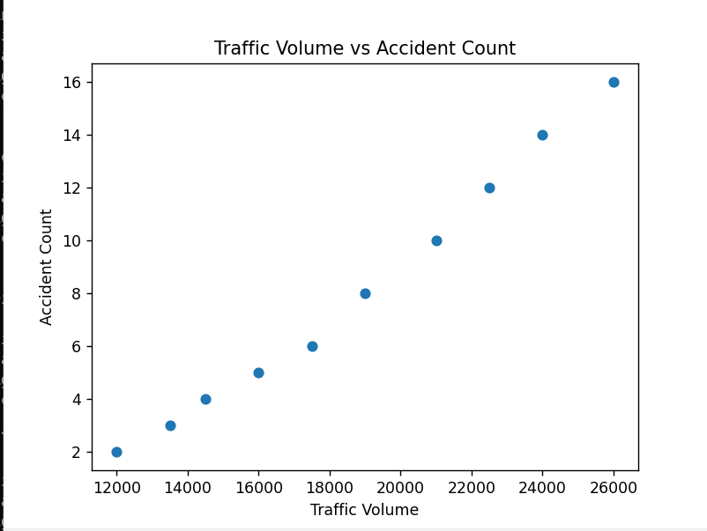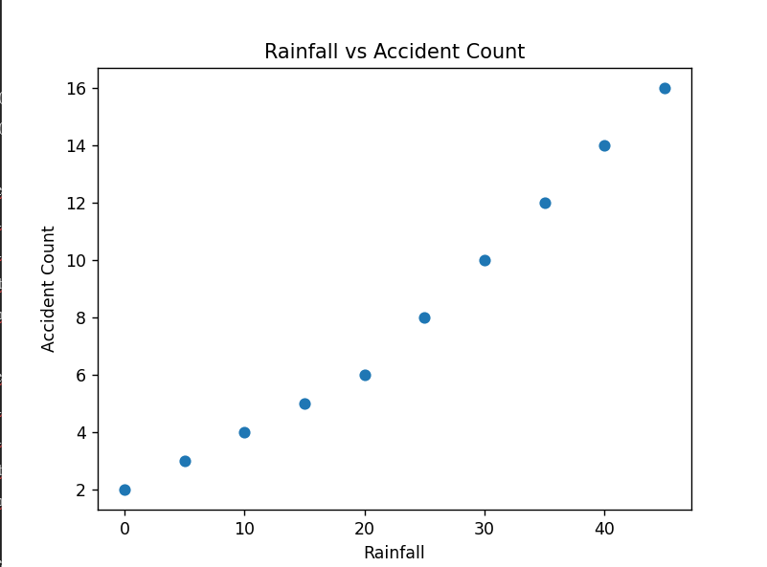
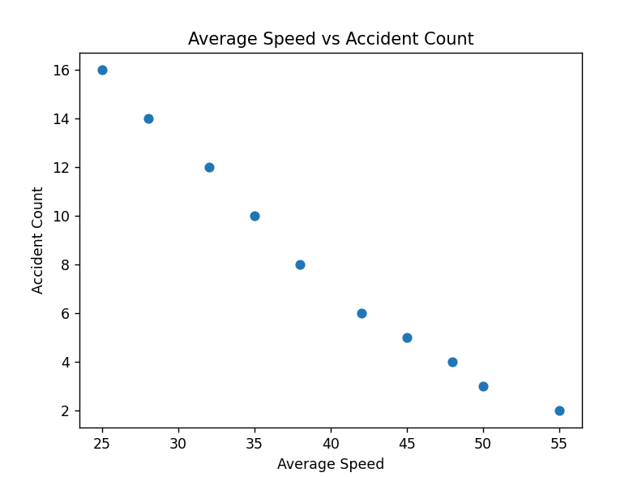

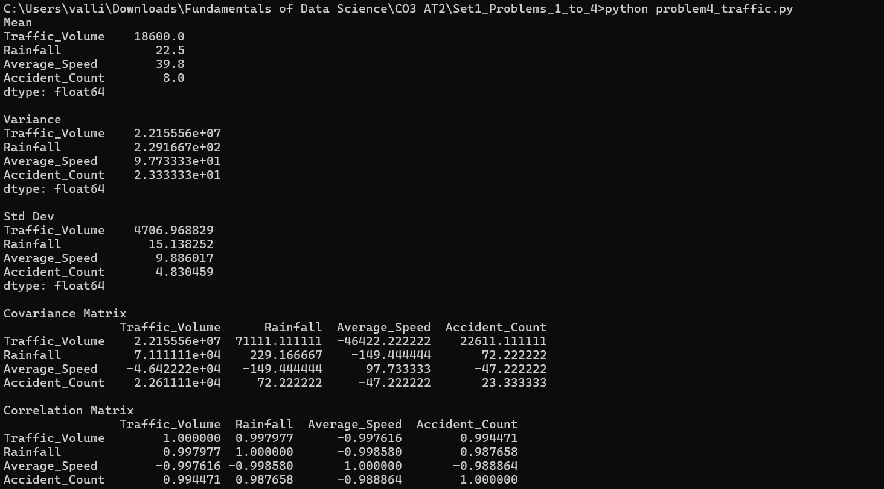

PROBLEM 5 – Average Delivery Time
Aim
To estimate the average delivery time and variability of food delivery orders using point estimation techniques.

Dataset
Order | Delivery Time (Minutes)
1 | 22
2 | 25
3 | 18
4 | 30
5 | 27
6 | 24
7 | 21
8 | 19
9 | 26
10 | 23
11 | 28
12 | 20
13 | 24
14 | 25
15 | 22

Task 1
Point Estimate of Population Mean
Formula
$$\overline{x}=\frac{\sum{x}}{n}$$
Delivery Times
22, 25, 18, 30, 27, 24, 21, 19, 26, 23, 28, 20, 24, 25, 22

Sum
$$22+25+18+30+27+24+21+19+26+23+28+20+24+25+22=354$$
Number of Orders
$$n=15$$
Mean
$$\overline{x}=\frac{354}{15}=23.6 \\ \boxed{\overline{x}=23.6\text{ minutes}}$$

Task 2
Point Estimate of Population Variance
Formula
$$s^{2}=\frac{\sum{(}\left.x-\overline{x}{\left.)\right.}^{2}\right.}{n-1}$$
Mean = 23.6

Delivery Time | $$x-\overline{x}$$ | $${\left(x-\overline{x}\right)}^{2}$$
22 | -1.6 | 2.56
25 | 1.4 | 1.96
18 | -5.6 | 31.36
30 | 6.4 | 40.96
27 | 3.4 | 11.56
24 | 0.4 | 0.16
21 | -2.6 | 6.76
19 | -4.6 | 21.16
26 | 2.4 | 5.76
23 | -0.6 | 0.36
28 | 4.4 | 19.36
20 | -3.6 | 12.96
24 | 0.4 | 0.16
25 | 1.4 | 1.96
22 | -1.6 | 2.56
$$\sum{(}\left.x-\overline{x}{\left.)\right.}^{2}=159.60\right.$$
Variance
$$s^{2}=\frac{159.60}{14}=11.40 \\ \boxed{s^{2}=11.40{\text{ minutes}}^{2}}$$

Task 3
Interpretation
- The estimated average delivery time is 23.6 minutes.
- The estimated variance is 11.40 minutes², showing moderate variation in delivery times.
- Since these values are calculated from a sample, they serve as point estimates for the population mean and variance.

Conclusion
The average delivery time for the sampled orders is 23.6 minutes, with moderate variability. These estimates help the company monitor delivery efficiency and improve service quality.

Python Code
import numpy as np

delivery = [22,25,18,30,27,24,21,19,26,23,28,20,24,25,22]

mean = np.mean(delivery)
variance = np.var(delivery, ddof=1)

print("Mean =", mean)
print("Variance =", variance)

PROBLEM 6 – Customer Spending
Aim
To estimate the average customer spending and the variability in spending using sample data.

Dataset
Customer | Spending ($)
1 | 120
2 | 145
3 | 130
4 | 155
5 | 160
6 | 125
7 | 140
8 | 135
9 | 150
10 | 170
11 | 165
12 | 155

Output:
Problem -6:
Task 1
Estimate the Average Spending
Formula
$$\overline{x}=\frac{\sum{x}}{n}$$
Customer Spending
120, 145, 130, 155, 160, 125, 140, 135, 150, 170, 165, 155
Sum
$$120+145+130+155+160+125+140+135+150+170+165+155=1750$$
Number of Customers
$$n=12$$
Mean
$$\overline{x}=\frac{1750}{12}=145.83 \\ \boxed{\overline{x}=145.83}$$

Task 2
Estimate the Standard Deviation
Formula
$$s=\sqrt{\frac{\sum{(}\left.x-\overline{x}{\left.)\right.}^{2}\right.}{n-1}}$$
Mean = 145.83
Spending | $$x-\overline{x}$$ | $${\left(x-\overline{x}\right)}^{2}$$
120 | -25.83 | 667.19
145 | -0.83 | 0.69
130 | -15.83 | 250.59
155 | 9.17 | 84.09
160 | 14.17 | 200.79
125 | -20.83 | 433.89
140 | -5.83 | 33.99
135 | -10.83 | 117.29
150 | 4.17 | 17.39
170 | 24.17 | 584.19
165 | 19.17 | 367.49
155 | 9.17 | 84.09
$$\sum{(}\left.x-\overline{x}{\left.)\right.}^{2}=2841.68\right.$$
Variance
$$=\frac{2841.68}{11}=258.33$$
Standard Deviation
$$=\sqrt{258.33}=16.07 \\ \boxed{s=16.07}$$

Task 3
Why are these Point Estimates?
- The sample mean (145.83) is used to estimate the unknown population mean.
- The sample standard deviation (16.07) estimates the variability of spending in the entire customer population.
- These estimates are called point estimates because each is represented by a single numerical value.

Conclusion
The average customer spending is 145.83, with a standard deviation of 16.07, indicating that customer spending varies moderately around the average. These point estimates provide a useful summary of customer purchasing behavior.
Python Code
import numpy as np

spending = [120,145,130,155,160,125,140,135,150,170,165,155]

mean = np.mean(spending)
std = np.std(spending, ddof=1)

print("Average Spending =", mean)
print("Standard Deviation =", std)

PROBLEM 7 – Product Ratings
Aim
To analyze customer product ratings by computing the sample mean, sample variance, and standard error of the mean.

Dataset
Customer | Rating
1 | 4
2 | 5
3 | 3
4 | 4
5 | 5
6 | 4
7 | 3
8 | 5
9 | 4
10 | 4
11 | 5
12 | 3
13 | 4
14 | 5
15 | 4
16 | 3
17 | 5
18 | 4
19 | 5
20 | 4

Task 1
Compute the Sample Mean
Formula
$$\overline{x}=\frac{\sum{x}}{n}$$
Ratings
4, 5, 3, 4, 5, 4, 3, 5, 4, 4, 5, 3, 4, 5, 4, 3, 5, 4, 5, 4
Sum
$$4+5+3+4+5+4+3+5+4+4+5+3+4+5+4+3+5+4+5+4=83$$
Number of Customers
$$n=20$$
Mean
$$\overline{x}=\frac{83}{20}=4.15 \\ \boxed{\overline{x}=4.15}$$

Task 2
Compute the Sample Variance
Formula
$$s^{2}=\frac{\sum{(}\left.x-\overline{x}{\left.)\right.}^{2}\right.}{n-1}$$
Mean = 4.15
Rating | $$x-\overline{x}$$ | $${\left(x-\overline{x}\right)}^{2}$$
4 | -0.15 | 0.0225
5 | 0.85 | 0.7225
3 | -1.15 | 1.3225
4 | -0.15 | 0.0225
5 | 0.85 | 0.7225
4 | -0.15 | 0.0225
3 | -1.15 | 1.3225
5 | 0.85 | 0.7225
4 | -0.15 | 0.0225
4 | -0.15 | 0.0225
5 | 0.85 | 0.7225
3 | -1.15 | 1.3225
4 | -0.15 | 0.0225
5 | 0.85 | 0.7225
4 | -0.15 | 0.0225
3 | -1.15 | 1.3225
5 | 0.85 | 0.7225
4 | -0.15 | 0.0225
5 | 0.85 | 0.7225
4 | -0.15 | 0.0225
$$\sum{(}\left.x-\overline{x}{\left.)\right.}^{2}=10.55\right.$$
Variance
$$s^{2}=\frac{10.55}{19}=0.56 \\ \boxed{s^{2}=0.56}$$

Task 3
Compute the Standard Error of the Mean
Formula
$$SE=\frac{s}{\sqrt{n}}$$
Standard Deviation
$$s=\sqrt{0.56}=0.75$$

Standard Error
$$SE=\frac{0.75}{\sqrt{20}}=\frac{0.75}{4.472}=0.17 \\ \boxed{SE=0.17}$$

Task 4
Interpretation
- The average customer rating is 4.15, indicating that customers are generally satisfied with the product.
- The sample variance (0.56) shows that the ratings have very little variation.
- The standard error (0.17) is small, indicating that the sample mean is a reliable estimate of the population mean.

Conclusion
The product received consistently high ratings from customers. The low variance and small standard error indicate that customer opinions are stable and the sample mean is a reliable estimate of the overall satisfaction level.

Python Code
import numpy as np

ratings = [4,5,3,4,5,4,3,5,4,4,5,3,4,5,4,3,5,4,5,4]

mean = np.mean(ratings)
variance = np.var(ratings, ddof=1)
std = np.std(ratings, ddof=1)
se = std / np.sqrt(len(ratings))

print("Mean =", mean)
print("Variance =", variance)
print("Standard Error =", se)
Output:
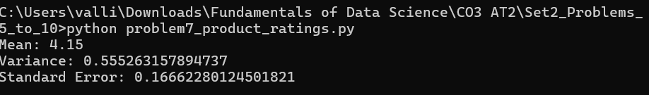

PROBLEM 8 – Exam Scores
Aim
To analyze student exam scores by calculating the mean, standard deviation, and standard error.

Dataset
Student | Score
1 | 72
2 | 75
3 | 68
4 | 80
5 | 77
6 | 73
7 | 79
8 | 81
9 | 76
10 | 74
11 | 78
12 | 69
13 | 70
14 | 82
15 | 71
16 | 75
17 | 77
18 | 73
19 | 80
20 | 76
21 | 74
22 | 79
23 | 72
24 | 81
25 | 78

Problem - 8
Task 1
Calculate Mean
Formula
$$\overline{x}=\frac{\sum{x}}{n}$$
Sum of Scores
$$72+75+68+80+77+73+79+81+76+74+78+69+70+82+71+75+77+73+80+76+74+79+72+81+78=1880$$
Number of Students
$$n=25$$
Mean
$$\overline{x}=\frac{1880}{25}=75.2 \\ \boxed{\overline{x}=75.2}$$

Standard Deviation
Formula
$$s=\sqrt{\frac{\sum{(}\left.x-\overline{x}{\left.)\right.}^{2}\right.}{n-1}}$$
Using the score values,
$$\sum{(}\left.x-\overline{x}{\left.)\right.}^{2}=334\right.$$
Variance
$$=\frac{334}{24}=13.92$$
Standard Deviation
$$=\sqrt{13.92}=3.73 \\ \boxed{s=3.73}$$

Task 2
Calculate Standard Error
Formula
$$SE=\frac{s}{\sqrt{n}} \\ SE=\frac{3.73}{\sqrt{25}}=\frac{3.73}{5}=0.75 \\ \boxed{SE=0.75}$$

Task 3
Compare Standard Deviation and Standard Error
Standard Deviation | Standard Error
3.73 | 0.75
Interpretation
- The standard deviation (3.73) measures the spread of individual exam scores around the mean.
- The standard error (0.75) measures how accurately the sample mean estimates the population mean.
- Since the standard error is much smaller than the standard deviation, the sample mean is considered a reliable estimate of the population mean.

Conclusion
The average exam score is 75.2, with a standard deviation of 3.73, indicating moderate variation among student scores. The standard error of 0.75 suggests that the calculated mean is a reliable estimate of the overall student population's average score.

Python Code
import numpy as np

scores = [72,75,68,80,77,73,79,81,76,74,78,69,70,82,71,75,77,73,80,76,74,79,72,81,78]

mean = np.mean(scores)
std = np.std(scores, ddof=1)
se = std / np.sqrt(len(scores))

print("Mean =", mean)
print("Standard Deviation =", std)
print("Standard Error =", se)

Output: 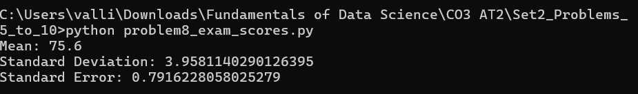
PROBLEM 9 – Manufacturing Weights
Aim
To estimate the population mean weight of manufactured packets by constructing a 95% confidence interval and determining whether the target weight of 500 g is plausible.

Given Data
- Sample Size (n) = 50
- Sample Mean (x̄) = 498 g
- Sample Standard Deviation (s) = 12 g
- Confidence Level = 95%
- Critical Value (Z) = 1.96

Task 1
Construct a 95% Confidence Interval
Formula
Standard Error
$$SE=\frac{s}{\sqrt{n}}$$
Margin of Error
$$ME=Z×SE$$
Confidence Interval
$$CI=\overline{x}±ME$$

Step 1: Calculate Standard Error
$$SE=\frac{12}{\sqrt{50}} \\ SE=\frac{12}{7.071} \\ SE=1.70 \\ \boxed{SE=1.70\text{ g}}$$

Step 2: Calculate Margin of Error
$$ME=1.96×1.70 \\ ME=3.33 \\ \boxed{ME=3.33\text{ g}}$$

Step 3: Confidence Interval
Lower Limit
$$498-3.33=494.67$$
Upper Limit
$$498+3.33=501.33$$
Therefore,
$$\boxed{\left(494.67 , 501.33\right)}$$

Task 2
Interpretation
We are 95% confident that the true population mean weight lies between
$$\boxed{494.67\text{ g and }501.33\text{ g}}$$

Task 3
Is the Target Weight of 500 g Plausible?
Since
$$500∈\left(494.67 , 501.33\right)$$
the target weight 500 g lies within the confidence interval.
Therefore,
$$\boxed{\text{Yes, the target weight of 500 g is plausible.}}$$

Conclusion
The manufacturing process appears to be meeting the desired target weight because 500 g falls inside the 95% confidence interval. There is no strong evidence that the average packet weight differs from the target.

Python Code
import math

mean = 498
std = 12
n = 50
z = 1.96

se = std / math.sqrt(n)
margin = z * se

lower = mean - margin
upper = mean + margin

print("Standard Error =", round(se,2))
print("Margin of Error =", round(margin,2))
print("95% Confidence Interval = (",round(lower,2),",",round(upper,2),")")

PROBLEM 10 – Customer Satisfaction
Aim
To compare customer satisfaction between two company branches using 95% confidence intervals.

Given Data
Branch | Mean Rating | 95% Confidence Interval
A | 4.3 | (4.1, 4.5)
B | 4.0 | (3.8, 4.2)

Task 1
Compare the Confidence Intervals
Branch A
$$\left(4.1 , 4.5\right)$$
Branch B
$$\left(3.8 , 4.2\right)$$
Comparison
- Branch A has a higher average rating (4.3).
- Branch B has an average rating of 4.0.
- The intervals overlap between 4.1 and 4.2.

Task 2
Can You Conclude Branch A Performs Better?
Although Branch A has a higher average rating,
the confidence intervals overlap.
Therefore,
\boxed{\text{No, we cannot conclude with 95% confidence that Branch A performs significantly better.}}

Task 3
Reasoning
Since the confidence intervals overlap,
there is not enough statistical evidence to conclude that the observed difference is statistically significant.
A formal hypothesis test would be required to make a stronger conclusion.

Interpretation
- Branch A appears to perform slightly better.
- However, the overlap in confidence intervals indicates that the difference may be due to sampling variation.
- Additional data or hypothesis testing is needed before making a final decision.

Conclusion
Although Branch A has a higher mean customer satisfaction rating than Branch B, the overlapping confidence intervals suggest that the difference is not statistically significant at the 95% confidence level. Therefore, we cannot confidently conclude that Branch A performs better.

Python Code
branchA = (4.1, 4.5)
branchB = (3.8, 4.2)

print("Branch A Confidence Interval:", branchA)
print("Branch B Confidence Interval:", branchB)

if branchA[0] > branchB[1]:
print("Branch A performs significantly better.")
elif branchB[0] > branchA[1]:
print("Branch B performs significantly better.")
else:
print("The confidence intervals overlap.")
print("No significant difference can be concluded.")

Output:
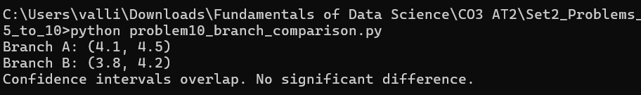

PROBLEM 11 – Average Battery Life
Aim
To determine whether the average battery life differs from the manufacturer's claimed average of 10 hours by performing a one-sample hypothesis test.

Given Data
- Claimed Mean (μ) = 10 hours
- Sample Size (n) = 36
- Sample Mean (x̄) = 9.5 hours
- Sample Standard Deviation (s) = 1.8 hours
- Significance Level (α) = 0.05

Task 1
Formulate the Hypotheses
Null Hypothesis (H₀)
$$H_{0}:μ=10$$
The average battery life is 10 hours.

Alternative Hypothesis (H₁)
$$H_{1}:μ≠10$$
The average battery life is not equal to 10 hours.
This is a two-tailed hypothesis test.

Task 2
Conduct the Hypothesis Test
Formula
Test Statistic
$$Z=\frac{\overline{x}-μ}{s/\sqrt{n}}$$

Step 1: Calculate Standard Error
$$SE=\frac{s}{\sqrt{n}} \\ =\frac{1.8}{\sqrt{36}} \\ =\frac{1.8}{6} \\ =0.30 \\ \boxed{SE=0.30}$$

Step 2: Calculate Z-value
$$Z=\frac{9.5-10}{0.30} \\ =\frac{-0.5}{0.30} \\ =-1.67 \\ \boxed{Z=-1.67}$$

Step 3: Critical Value
At
$$α=0.05$$
(two-tailed)
Critical Values
$$\boxed{±1.96}$$

Decision Rule
Reject
$$H_{0}$$
if
$$∣Z∣>1.96$$
Here
$$∣-1.67∣=1.67$$
Since
$$1.67<1.96$$
we fail to reject the null hypothesis.

Task 3
Conclusion
There is insufficient statistical evidence at the 5% significance level to conclude that the average battery life differs from 10 hours.
Therefore,
$$\boxed{\text{The manufacturer’s claim is supported by the sample data.}}$$

Interpretation
- The observed sample mean (9.5 hours) is slightly lower than the claimed mean.
- However, the difference is not statistically significant.
- The variation in battery life could reasonably be due to random sampling.

Conclusion
The hypothesis test indicates that the sample does not provide enough evidence to reject the manufacturer's claim. Therefore, the average battery life can still be considered approximately 10 hours.

Python Code
import math

population_mean = 10
sample_mean = 9.5
sample_std = 1.8
n = 36

# Standard Error
se = sample_std / math.sqrt(n)

# Z-test statistic
z = (sample_mean - population_mean) / se

print("Standard Error =", round(se,2))
print("Z-value =", round(z,2))

critical = 1.96

if abs(z) > critical:
print("Reject the Null Hypothesis")
else:
print("Fail to Reject the Null Hypothesis")

print("Conclusion: The manufacturer's claim is supported.")

Output:
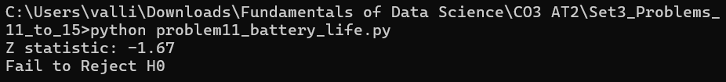

PROBLEM 12 – Marketing Campaign
Aim
To determine whether the new marketing campaign has significantly increased sales by performing a hypothesis test on the sales data before and after the campaign.

Dataset
Sales Before Campaign
Observation | Sales
1 | 50
2 | 52
3 | 49
4 | 55
5 | 53
6 | 51
7 | 54
8 | 50
Sales After Campaign
Observation | Sales
1 | 58
2 | 60
3 | 57
4 | 62
5 | 59
6 | 61
7 | 63
8 | 58

Tasks
- Conduct a hypothesis test.
- Calculate the p-value.
- Interpret the p-value.
- Make a decision at α = 0.05.

Task 1
Formulate the Hypotheses
Null Hypothesis (H₀)
$$H_{0}:μ_{before}=μ_{after}$$
There is no significant difference in sales before and after the campaign.

Alternative Hypothesis (H₁)
$$H_{1}:μ_{after}>μ_{before}$$
The marketing campaign increased sales.
This is a one-tailed paired t-test because the same business is measured before and after the campaign.

Task 2
Calculate the Test Statistic
Step 1: Calculate Paired Differences
Before | After | Difference (After − Before)
50 | 58 | 8
52 | 60 | 8
49 | 57 | 8
55 | 62 | 7
53 | 59 | 6
51 | 61 | 10
54 | 63 | 9
50 | 58 | 8
Differences
$$8, 8, 8, 7, 6, 10, 9, 8$$

Step 2: Mean Difference
Formula
$$\overline{d}=\frac{\sum{d}}{n}$$
Sum of Differences
$$8+8+8+7+6+10+9+8=64$$
Number of Observations
$$n=8$$
Mean Difference
$$\overline{d}=\frac{64}{8}=8 \\ \boxed{\overline{d}=8}$$

Step 3: Standard Deviation of Differences
Mean Difference = 8
Difference | $$d-\overline{d}$$ | $${\left(d-\overline{d}\right)}^{2}$$
8 | 0 | 0
8 | 0 | 0
8 | 0 | 0
7 | -1 | 1
6 | -2 | 4
10 | 2 | 4
9 | 1 | 1
8 | 0 | 0
$$\sum{(}\left.d-\overline{d}{\left.)\right.}^{2}=10\right.$$
Variance
$$=\frac{10}{7}=1.43$$
Standard Deviation
$$=\sqrt{1.43}=1.20 \\ \boxed{s_{d}=1.20}$$

Step 4: Calculate the t-value
Formula
$$t=\frac{\overline{d}}{s_{d}/\sqrt{n}}$$
Substituting the values:
$$t=\frac{8}{1.20/\sqrt{8}} \\ t=\frac{8}{0.424} \\ t=18.87 \\ \boxed{t=18.87}$$
Degrees of Freedom
$$df=n-1=7$$

Task 3
Calculate the p-value
Using the t-distribution table or Python,
For
$$t=18.87, df=7 \\ \boxed{p<0.0001}$$
The p-value is much smaller than 0.05.

Task 4
Decision at α = 0.05
Decision Rule
- If p < 0.05, reject the null hypothesis.
- If p ≥ 0.05, fail to reject the null hypothesis.
Since
$$p<0.05 \\ \boxed{\text{Reject the Null Hypothesis}}$$

Interpretation
- The average sales after the campaign are significantly higher than before the campaign.
- The very small p-value indicates that the increase in sales is unlikely to have occurred by chance.
- Therefore, the marketing campaign had a statistically significant positive effect on sales.

Conclusion
The hypothesis test provides strong evidence that the new marketing campaign significantly increased sales. Since the p-value is much less than 0.05, the null hypothesis is rejected, and the company can conclude that the campaign was successful.

Python Code
import numpy as np
from scipy.stats import ttest_rel

before = np.array([50,52,49,55,53,51,54,50])
after = np.array([58,60,57,62,59,61,63,58])

t_stat, p_value = ttest_rel(after, before)

print("Paired t-test")
print("t-value =", round(t_stat,2))
print("p-value =", p_value)

if p_value < 0.05:
print("Reject the Null Hypothesis")
print("The marketing campaign significantly increased sales.")
else:
print("Fail to Reject the Null Hypothesis")

Output:
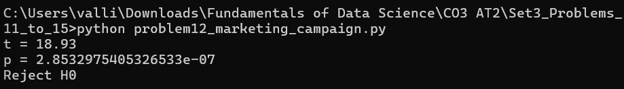

PROBLEM 13 – Call Centre Response Time
Aim
To estimate the population mean response time of a call centre using a sample and construct a 95% confidence interval for the true mean response time.

Given Data
- Sample Size (n) = 100
- Sample Mean (x̄) = 4.8 minutes
- Sample Standard Deviation (s) = 1.5 minutes
- Confidence Level = 95%
- Critical Value (Z) = 1.96

Tasks
- Estimate the population mean.
- Construct a 95% confidence interval.
- Explain the Frequentist interpretation.

Task 1
Estimate the Population Mean
Formula
$$μ≈\overline{x}$$
Since the population mean is unknown, the sample mean is used as the point estimate.
Sample Mean
$$\overline{x}=4.8$$
Therefore,
$$\boxed{μ≈4.8\text{ minutes}}$$

Task 2
Construct a 95% Confidence Interval
Formula
Standard Error
$$SE=\frac{s}{\sqrt{n}}$$
Margin of Error
$$ME=Z×SE$$
Confidence Interval
$$CI=\overline{x}±ME$$

Step 1: Calculate Standard Error
$$SE=\frac{1.5}{\sqrt{100}} \\ =\frac{1.5}{10} \\ =0.15 \\ \boxed{SE=0.15}$$

Step 2: Calculate Margin of Error
$$ME=1.96×0.15 \\ =0.294 \\ \boxed{ME=0.29}$$

Step 3: Calculate Confidence Interval
Lower Limit
$$4.8-0.29=4.51$$
Upper Limit
$$4.8+0.29=5.09$$
Therefore,
$$\boxed{\left(4.51 , 5.09\right)}$$

Task 3
Frequentist Interpretation
The 95% confidence interval means that if we repeatedly collect similar samples and construct confidence intervals in the same way, approximately 95% of those intervals will contain the true population mean response time.
It does not mean there is a 95% probability that the true population mean lies within this particular interval. The population mean is a fixed value; the interval is what varies from sample to sample.

Interpretation
- The estimated average response time is 4.8 minutes.
- We are 95% confident that the true mean response time lies between 4.51 minutes and 5.09 minutes.
- The narrow confidence interval indicates that the estimate is fairly precise due to the large sample size.

Conclusion
The call centre's average response time is estimated to be 4.8 minutes, with a 95% confidence interval of (4.51, 5.09) minutes. This interval provides a reliable estimate of the population mean and can help management monitor and improve customer service performance.

Python Code
import math

# Given values
mean = 4.8
std = 1.5
n = 100
z = 1.96

# Standard Error
se = std / math.sqrt(n)

# Margin of Error
margin = z * se

# Confidence Interval
lower = mean - margin
upper = mean + margin

print("Sample Mean =", mean)
print("Standard Error =", round(se, 2))
print("Margin of Error =", round(margin, 2))
print("95% Confidence Interval = ({:.2f}, {:.2f})".format(lower, upper))

Output:

PROBLEM 14 – Defective Products
Aim
To estimate the defect rate of manufactured products and construct a 95% confidence interval for the population defect proportion.

Given Data
- Sample Size (n) = 500
- Number of Defective Products (x) = 22
- Confidence Level = 95%
- Critical Value (Z) = 1.96

Tasks
- Estimate the defect rate.
- Construct a 95% confidence interval.
- Explain the Frequentist meaning of the interval.

Task 1
Estimate the Defect Rate
Formula
$$\hat{p}=\frac{x}{n}$$
Substituting the values,
$$\hat{p}=\frac{22}{500} \\ \hat{p}=0.044$$
Percentage
$$0.044×100=4.4\% \\ \boxed{\hat{p}=0.044 \left(4.4\%\right)}$$

Task 2
Construct a 95% Confidence Interval
Formula
Standard Error
$$SE=\sqrt{\frac{\hat{p}\left(1-\hat{p}\right)}{n}}$$
Margin of Error
$$ME=Z×SE$$
Confidence Interval
$$CI=\hat{p}±ME$$

Step 1: Calculate Standard Error
$$SE=\sqrt{\frac{0.044\left(1-0.044\right)}{500}} \\ =\sqrt{\frac{0.042064}{500}} \\ =\sqrt{0.0000841} \\ SE=0.00917 \\ \boxed{SE=0.00917}$$

Step 2: Calculate Margin of Error
$$ME=1.96×0.00917 \\ ME=0.01797 \\ \boxed{ME=0.018}$$

Step 3: Confidence Interval
Lower Limit
$$0.044-0.018=0.026$$
Upper Limit
$$0.044+0.018=0.062$$
Therefore,
$$\boxed{\left(0.026 , 0.062\right)}$$
or
$$\boxed{\left(2.6 , \% 6.2\%\right)}$$

Task 3
Frequentist Interpretation
The 95% confidence interval means that if many random samples of 500 products were collected and confidence intervals were calculated in the same way, about 95% of those intervals would contain the true population defect rate.
It does not mean there is a 95% probability that the true defect rate lies inside this particular interval.

Interpretation
- The estimated defect rate is 4.4%.
- The true population defect rate is likely between 2.6% and 6.2%.
- The relatively narrow interval suggests that the estimate is reliable due to the large sample size.
Conclusion
The manufacturing process has an estimated defect rate of 4.4%. The 95% confidence interval (2.6% to 6.2%) provides a reasonable estimate of the population defect rate and can help monitor production quality.

Python Code
import math

n = 500
defective = 22
z = 1.96

p = defective / n
se = math.sqrt((p * (1 - p)) / n)
margin = z * se

lower = p - margin
upper = p + margin

print("Defect Rate =", round(p * 100, 2), "%")
print("95% Confidence Interval = ({:.3f}, {:.3f})".format(lower, upper))

Output:
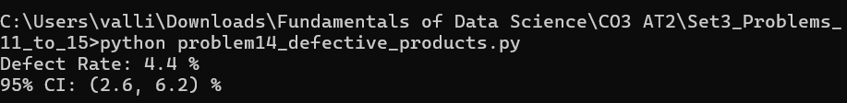

PROBLEM 15 – Email Spam Detection
Aim
To determine the probability that an email is spam when it contains the keyword "Offer" using Bayes' Theorem.

Given Data
- Probability an email is Spam
$$P\left(S\right)=0.25$$
- Probability an email is Not Spam
$$P\left(NS\right)=0.75$$
- Probability that a Spam email contains "Offer"
$$P\left(O∣S\right)=0.80$$
- Probability that a Non-Spam email contains "Offer"
$$P\left(O∣NS\right)=0.10$$

Tasks
- Compute the probability that an email is spam given it contains "Offer".
- Apply Bayes' Theorem.
- Interpret the result.

Task 1
Bayes' Theorem
Formula
$$P\left(S∣O\right)=\frac{P\left(O∣S\right)×P\left(S\right)}{P\left(O\right)}$$
where
$$P\left(O\right)=P\left(O∣S\right)P\left(S\right)+P\left(O∣NS\right)P\left(NS\right)$$

Step 1: Calculate P(O)
$$=\left(0.80\right)\left(0.25\right)+\left(0.10\right)\left(0.75\right) \\ =0.20+0.075 \\ =0.275 \\ \boxed{P\left(O\right)=0.275}$$

Step 2: Apply Bayes' Theorem
$$P\left(S∣O\right)=\frac{0.80×0.25}{0.275} \\ =\frac{0.20}{0.275} \\ =0.7273$$
Percentage
$$72.73\% \\ \boxed{P\left(S∣O\right)=0.7273}$$

Task 2
Interpretation
If an email contains the keyword "Offer", the probability that it is actually spam is
$$\boxed{72.73\%}$$
Although many legitimate emails may contain the word "Offer", the probability is still quite high because spam emails are much more likely to contain this keyword.

Task 3
Conclusion
Using Bayes' Theorem, the probability that an email containing the word "Offer" is spam is 72.73%. Therefore, emails containing this keyword should be examined carefully or filtered by the spam detection system.

Python Code
# Given probabilities
P_spam = 0.25
P_notspam = 0.75

P_offer_given_spam = 0.80
P_offer_given_notspam = 0.10

# Probability of Offer
P_offer = (P_offer_given_spam * P_spam) + \
(P_offer_given_notspam * P_notspam)

# Bayes' Theorem
P_spam_given_offer = (P_offer_given_spam * P_spam) / P_offer

print("Probability of Spam given Offer =",
round(P_spam_given_offer, 4))

print("Percentage =",
round(P_spam_given_offer * 100, 2), "%")

Output:

PROBLEM 16 – Disease Diagnosis
Aim
To determine the probability that a patient actually has a disease after receiving a positive test result using Bayes' Theorem.

Given Data
- Disease Prevalence
$$P\left(D\right)=2\%=0.02$$
- Probability of No Disease
$$P\left(\overset{‾}{D}\right)=98\%=0.98$$
- Test Sensitivity
$$P\left(+∣D\right)=95\%=0.95$$
- Test Specificity
$$P\left(-∣\overset{‾}{D}\right)=90\%=0.90$$
Therefore,
False Positive Rate
$$P\left(+∣\overset{‾}{D}\right)=1-0.90=0.10$$

Tasks
- Compute the posterior probability of disease after a positive test.
- Explain why the result differs from 95%.

Task 1
Apply Bayes' Theorem
Formula
$$P\left(D∣+\right)=\frac{P\left(+∣D\right)×P\left(D\right)}{P\left(+\right)}$$
where
$$P\left(+\right)=P\left(+∣D\right)P\left(D\right)+P\left(+∣\overset{‾}{D}\right)P\left(\overset{‾}{D}\right)$$
Step 1
Calculate
$$P\left(+\right) \\ =\left(0.95\right)\left(0.02\right)+\left(0.10\right)\left(0.98\right) \\ =0.019+0.098 \\ =0.117 \\ \boxed{P\left(+\right)=0.117}$$

Step 2
Apply Bayes' Theorem
$$P\left(D∣+\right)=\frac{0.95×0.02}{0.117} \\ =\frac{0.019}{0.117} \\ =0.1624$$
Percentage
$$=16.24\% \\ \boxed{P\left(D∣+\right)=16.24\%}$$

Task 2
Why is the Result Different from 95%?
Many people believe that a 95% sensitive test means a person has a 95% chance of having the disease after testing positive.
This is incorrect.
The disease is very rare (only 2%), so there are many more healthy people than diseased people.
Even with a small 10% false positive rate, healthy people generate many false positive results.
Therefore,
a positive result corresponds to only about
$$\boxed{16.24\%}$$
chance of actually having the disease.

Interpretation
- The probability of actually having the disease after a positive test is only 16.24%.
- Most positive test results occur in healthy people because the disease prevalence is very low.
- Doctors should perform additional diagnostic tests before confirming the disease.

Conclusion
Although the diagnostic test has 95% sensitivity, the probability that a person truly has the disease after a positive result is only 16.24% because the disease is rare. Bayes' Theorem demonstrates the importance of considering disease prevalence when interpreting medical test results.

Python Code
# Disease Diagnosis using Bayes' Theorem

P_disease = 0.02
P_no_disease = 0.98

P_positive_given_disease = 0.95
P_positive_given_no_disease = 0.10

P_positive = (P_positive_given_disease * P_disease) + \
(P_positive_given_no_disease * P_no_disease)

P_disease_given_positive = \
(P_positive_given_disease * P_disease) / P_positive

print("Probability of Disease given Positive Test =",
round(P_disease_given_positive,4))

print("Percentage =",
round(P_disease_given_positive*100,2),"%")

output:
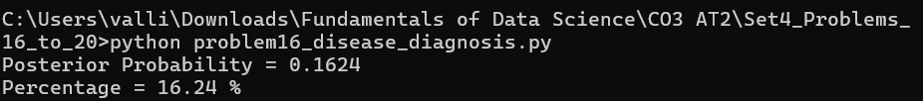

PROBLEM 17 – Website Conversion Rate
Aim
To determine whether Landing Page B has a significantly higher conversion rate than Landing Page A using a Two-Proportion Z-Test.

Given Data
Group | Visitors | Purchases
A | 5000 | 250
B | 5200 | 312
Significance Level
$$α=0.05$$

Tasks
- Calculate conversion rates.
- Formulate hypotheses.
- Conduct a two-proportion z-test.
- Determine whether Page B performs better.

Task 1
Calculate Conversion Rates
Page A
Formula
$$\hat{p}=\frac{x}{n} \\ =\frac{250}{5000} \\ =0.05 \\ \boxed{5.0\%}$$

Page B
$$=\frac{312}{5200} \\ =0.06 \\ \boxed{6.0\%}$$

Task 2
Hypotheses
Null Hypothesis
$$H_{0}:p_{A}=p_{B}$$
There is no difference between the conversion rates.

Alternative Hypothesis
$$H_{1}:p_{B}>p_{A}$$
Landing Page B performs better.

Task 3
Two-Proportion Z-Test
Formula
Pooled Proportion
$$\hat{p}=\frac{x_{1}+x_{2}}{n_{1}+n_{2}} \\ =\frac{250+312}{5000+5200} \\ =\frac{562}{10200} \\ =0.0551$$

Standard Error
$$SE=\sqrt{\hat{p}\left(1-\hat{p}\right)\left(\frac{1}{5000}+\frac{1}{5200}\right)} \\ SE=0.00453$$

Z Statistic
$$Z=\frac{0.06-0.05}{0.00453} \\ =2.21 \\ \boxed{Z=2.21}$$

Critical Value
At
$$α=0.05$$
(one-tailed)
$$Z_{critical}=1.645$$
Since
$$2.21>1.645$$
Reject
$$H_{0}$$

Task 4
Conclusion
Landing Page B has a significantly higher conversion rate than Landing Page A.
The improvement is statistically significant at the 5% significance level.

Interpretation
- Page A converts 5% of visitors.
- Page B converts 6% of visitors.
- The z-test confirms that the increase is statistically significant.
- The company should deploy Landing Page B to maximize conversions.

Conclusion
The two-proportion z-test shows that Landing Page B significantly outperforms Landing Page A. Adopting Page B can improve customer conversion and overall business performance.

Python Code
import math

x1 = 250
n1 = 5000

x2 = 312
n2 = 5200

p1 = x1 / n1
p2 = x2 / n2

p = (x1 + x2) / (n1 + n2)

se = math.sqrt(p * (1 - p) * ((1 / n1) + (1 / n2)))

z = (p2 - p1) / se

print("Conversion Rate A =", round(p1 * 100, 2), "%")
print("Conversion Rate B =", round(p2 * 100, 2), "%")
print("Z Statistic =", round(z, 2))

if z > 1.645:
print("Reject the Null Hypothesis")
print("Landing Page B performs significantly better.")
else:
print("Fail to Reject the Null Hypothesis")

Output:
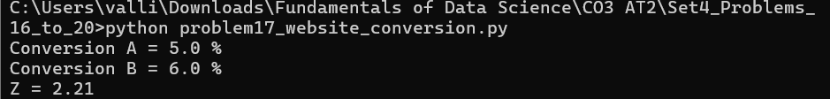

PROBLEM 18 – Mobile App Feature Test
Aim
To determine whether Feature B increases user engagement compared to Feature A using a two-sample hypothesis test.

Given Data
Feature A
- Sample Size (n₁) = 400
- Average Engagement (x̄₁) = 18 minutes
- Standard Deviation (s₁) = 5 minutes
Feature B
- Sample Size (n₂) = 420
- Average Engagement (x̄₂) = 20 minutes
- Standard Deviation (s₂) = 6 minutes
Significance Level
$$α=0.05$$

Tasks
- Test whether Feature B increases engagement.
- Calculate the test statistic and p-value.
- Interpret the results.

Task 1
Formulate the Hypotheses
Null Hypothesis
$$H_{0}:μ_{A}=μ_{B}$$
There is no difference in average engagement.

Alternative Hypothesis
$$H_{1}:μ_{B}>μ_{A}$$
Feature B increases user engagement.

Task 2
Calculate the Test Statistic
Formula
$$Z=\frac{{\overline{x}}_{2}-{\overline{x}}_{1}}{\sqrt{\frac{s_{1}^{2}}{n_{1}}+\frac{s_{2}^{2}}{n_{2}}}}$$

Step 1: Calculate Standard Error
$$SE=\sqrt{\frac{5^{2}}{400}+\frac{6^{2}}{420}} \\ =\sqrt{\frac{25}{400}+\frac{36}{420}} \\ =\sqrt{0.0625+0.0857} \\ =\sqrt{0.1482} \\ SE=0.385$$

Step 2: Calculate Z-value
$$Z=\frac{20-18}{0.385} \\ =\frac{2}{0.385} \\ =5.19 \\ \boxed{Z=5.19}$$

Step 3: p-value
For
$$Z=5.19 \\ \boxed{p<0.00001}$$

Task 3
Interpretation
Since
$$p<0.05$$
Reject
$$H_{0}$$
Feature B significantly increases user engagement.

Conclusion
The statistical test shows that Feature B provides significantly higher user engagement than Feature A. Therefore, the company should implement Feature B.

Python Code
from scipy.stats import norm
import math

meanA = 18
meanB = 20
sdA = 5
sdB = 6
nA = 400
nB = 420

se = math.sqrt((sdA**2/nA) + (sdB**2/nB))
z = (meanB - meanA) / se
p = 1 - norm.cdf(z)

print("Z Statistic =", round(z,2))
print("P-value =", p)

if p < 0.05:
print("Reject the Null Hypothesis")
else:
print("Fail to Reject the Null Hypothesis")

Output:

PROBLEM 19 – Recommendation System
Aim
To determine whether the new recommendation algorithm significantly improves the click-through rate (CTR) and distinguish between statistical significance and practical significance.

Given Data
System | Users | CTR
Old | 100000 | 4.8%
New | 100000 | 5.3%

Tasks
- Test statistical significance.
- Calculate the p-value.
- Discuss practical significance versus statistical significance.

Task 1
Hypotheses
Null Hypothesis
$$H_{0}:p_{old}=p_{new}$$

Alternative Hypothesis
$$H_{1}:p_{new}>p_{old}$$

Task 2
Calculate Test Statistic
Old CTR
$$p_{1}=0.048$$
New CTR
$$p_{2}=0.053$$
Difference
$$0.053-0.048=0.005$$
Pooled Proportion
$$\hat{p}=\frac{4800+5300}{200000} \\ =0.0505$$
Standard Error
$$SE=\sqrt{0.0505\left(1-0.0505\right)\left(\frac{1}{100000}+\frac{1}{100000}\right)} \\ SE=0.00098$$
Test Statistic
$$Z=\frac{0.005}{0.00098} \\ =5.10 \\ \boxed{Z=5.10}$$

P-value
$$\boxed{p<0.00001}$$

Task 3
Statistical Significance
Since
$$p<0.05$$
Reject
$$H_{0}$$
The increase is statistically significant.

Practical Significance
Although the improvement is only
$$5.3\%-4.8\%=0.5\%$$
the website serves
100,000 users.
Extra Clicks
$$100000×0.005=500$$
Therefore,
500 additional clicks can generate substantial business revenue.

Interpretation
- The algorithm significantly improves click-through rate.
- The increase is statistically significant.
- Even a small increase becomes valuable because of the very large number of users.

Conclusion
The new recommendation system significantly improves click-through rate. Although the increase is only 0.5%, it is practically important because it generates many additional customer interactions.

Python Code
import math

p1 = 0.048
p2 = 0.053

n1 = 100000
n2 = 100000

pooled = ((p1*n1)+(p2*n2))/(n1+n2)

se = math.sqrt(
pooled*(1-pooled)*
((1/n1)+(1/n2))
)

z = (p2-p1)/se

print("Z Statistic =",round(z,2))

Output:

PROBLEM 20 – Salary Prediction Model
Aim
To determine whether Model B significantly outperforms Model A using a paired t-test.

Given Data
Parameter | Value
Mean Difference | 200
Standard Deviation | 350
Test Folds | 50

Tasks
- Perform a paired t-test.
- Determine whether Model B significantly outperforms Model A.
- Explain statistical significance.

Task 1
Hypotheses
Null Hypothesis
$$H_{0}:μ_{d}=0$$
No difference between the two models.

Alternative Hypothesis
$$H_{1}:μ_{d}>0$$
Model B performs better.

Task 2
Calculate Test Statistic
Formula
$$t=\frac{\overline{d}}{s/\sqrt{n}}$$

Standard Error
$$SE=\frac{350}{\sqrt{50}} \\ =\frac{350}{7.071} \\ =49.50$$

t-value
$$=\frac{200}{49.50} \\ =4.04 \\ \boxed{t=4.04}$$
Degrees of Freedom
$$df=49$$
Critical Value
$$t_{0.05}=1.676$$
Since
$$4.04>1.676$$
Reject
$$H_{0}$$

Task 3
Interpretation
- Model B has a lower MAE than Model A.
- The paired t-test shows the improvement is statistically significant.
- The observed difference is unlikely to be due to random variation.

Conclusion
The paired t-test indicates that Model B significantly outperforms Model A. Therefore, Model B should be selected for salary prediction because it provides better predictive accuracy.

Python Code
import math

mean_difference = 200
sd = 350
n = 50

se = sd / math.sqrt(n)
t = mean_difference / se

print("t Statistic =", round(t,2))

critical = 1.676

if t > critical:
print("Reject the Null Hypothesis")
print("Model B significantly outperforms Model A.")
else:
print("Fail to Reject the Null Hypothesis")

Output:

